Thread 9d1bad67
Source: https://my.remarkbox.com/9d1bad67-9fc8-11ec-a49f-b1c8c4ae987e
Snapshot: 2026-05-09T16:50:34Z
Generator: Remarkbox 763cacb
This is a subthread snapshot. The living document lives at the source URI above — it may have been edited, extended, or replied-to since.
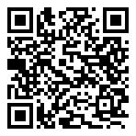
Scan for living source
Our problem was due to AT&T closing 3G cell towers. Once we switched to T-Mobile, our phone service was restored.

Source: https://my.remarkbox.com/9d1bad67-9fc8-11ec-a49f-b1c8c4ae987e
Snapshot: 2026-05-09T16:50:34Z
Generator: Remarkbox 763cacb

