Thread 9d6803eb
Source: https://my.remarkbox.com/9d6803eb-f146-11eb-9971-040140774501
Snapshot: 2026-05-03T12:10:27Z
Generator: Remarkbox 763cacb
This is a subthread snapshot. The living document lives at the source URI above — it may have been edited, extended, or replied-to since.
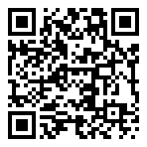
Scan for living source
When did outages start? I destroyed my phone, thinking it had failed! I am pissed!

Source: https://my.remarkbox.com/9d6803eb-f146-11eb-9971-040140774501
Snapshot: 2026-05-03T12:10:27Z
Generator: Remarkbox 763cacb

