Thread a72c1380
Source: https://my.remarkbox.com/a72c1380-3816-11ee-a90d-83aad5f5c937
Snapshot: 2026-05-03T10:48:44Z
Generator: Remarkbox 763cacb
This is a subthread snapshot. The living document lives at the source URI above — it may have been edited, extended, or replied-to since.
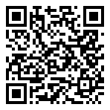
Scan for living source
I live in Plainview, AR and recently have lost service with QLink Wireless

Source: https://my.remarkbox.com/a72c1380-3816-11ee-a90d-83aad5f5c937
Snapshot: 2026-05-03T10:48:44Z
Generator: Remarkbox 763cacb

