Thread a99e0935
Source: https://my.remarkbox.com/a99e0935-a223-11ef-8e33-29ab4fb285a0
Snapshot: 2026-05-03T09:26:55Z
Generator: Remarkbox 763cacb
This is a subthread snapshot. The living document lives at the source URI above — it may have been edited, extended, or replied-to since.
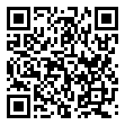
Scan for living source
My qlink network is not allowing me to make outgoing calls or receiving incoming calls. Message that I'm out of time, but I'm on lifeline and shows in settings that I've only used 236/1000 minutes.

Source: https://my.remarkbox.com/a99e0935-a223-11ef-8e33-29ab4fb285a0
Snapshot: 2026-05-03T09:26:55Z
Generator: Remarkbox 763cacb

