Thread b64b0f2a
Source: https://my.remarkbox.com/b64b0f2a-db2b-11eb-af1e-040140774501
Snapshot: 2026-05-03T09:26:42Z
Generator: Remarkbox 763cacb
This is a subthread snapshot. The living document lives at the source URI above — it may have been edited, extended, or replied-to since.
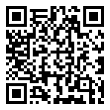
Scan for living source
No service in Linwood, KS. Haven't had any since Saturday. I realize the service is free for me, however, I have no other phone and rely on this for my Life Alert line as well.

Source: https://my.remarkbox.com/b64b0f2a-db2b-11eb-af1e-040140774501
Snapshot: 2026-05-03T09:26:42Z
Generator: Remarkbox 763cacb

