Thread b74f7b3f
Source: https://my.remarkbox.com/b74f7b3f-8a57-11ef-9b62-29ab4fb285a0
Snapshot: 2026-05-03T10:46:22Z
Generator: Remarkbox 763cacb
This is a subthread snapshot. The living document lives at the source URI above — it may have been edited, extended, or replied-to since.
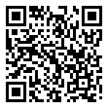
Scan for living source
My cellular service has been down for approximately 20 hours. I cannot connect to Wi-Fi for that type of calling. Text messages are also not working. Wifi is on and I can get email.

Source: https://my.remarkbox.com/b74f7b3f-8a57-11ef-9b62-29ab4fb285a0
Snapshot: 2026-05-03T10:46:22Z
Generator: Remarkbox 763cacb

