Thread b89086c5
Source: https://my.remarkbox.com/b89086c5-8ba0-11ed-91c4-83aad5f5c937
Snapshot: 2026-04-27T22:33:27Z
Generator: Remarkbox 763cacb
This is a subthread snapshot. The living document lives at the source URI above — it may have been edited, extended, or replied-to since.
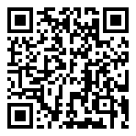
Scan for living source
No Service for my Great Call Jitterbug cell. Everett, WA

9PHjDtfD — Feb 03, 2023 02:32 am
My service is also down in east Texas 50 miles east of Austin. It's been out since the ice storm Wednesday.

Source: https://my.remarkbox.com/b89086c5-8ba0-11ed-91c4-83aad5f5c937
Snapshot: 2026-04-27T22:33:27Z
Generator: Remarkbox 763cacb

