Thread b966ef38
Source: https://my.remarkbox.com/b966ef38-d9e6-11eb-add2-040140774501
Snapshot: 2026-05-03T10:47:25Z
Generator: Remarkbox 763cacb
This is a subthread snapshot. The living document lives at the source URI above — it may have been edited, extended, or replied-to since.
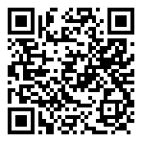
Scan for living source
I dpn't think so. It says it's going to be beneficial to its users. I know I have a T-Mobile Sim card in my phone and T-mobile is down in my area.

Source: https://my.remarkbox.com/b966ef38-d9e6-11eb-add2-040140774501
Snapshot: 2026-05-03T10:47:25Z
Generator: Remarkbox 763cacb

