Thread bd095ca7
Source: https://my.remarkbox.com/bd095ca7-e25e-11eb-b78f-040140774501
Snapshot: 2026-05-03T09:25:13Z
Generator: Remarkbox 763cacb
This is a subthread snapshot. The living document lives at the source URI above — it may have been edited, extended, or replied-to since.
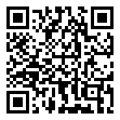
Scan for living source
Network has not worked since Sat morning. Zip code 30013. When will it be up again?

Source: https://my.remarkbox.com/bd095ca7-e25e-11eb-b78f-040140774501
Snapshot: 2026-05-03T09:25:13Z
Generator: Remarkbox 763cacb

