Thread c13335a3
Source: https://my.remarkbox.com/c13335a3-50cf-11ee-907e-83aad5f5c937
Snapshot: 2026-05-09T16:52:04Z
Generator: Remarkbox 763cacb
This is a subthread snapshot. The living document lives at the source URI above — it may have been edited, extended, or replied-to since.
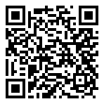
Scan for living source
In Niagara-on-the-Lake ON. My service is down. Only garbled speech and no voicemail. L0S 1J0 postal code 289-783-2772

Source: https://my.remarkbox.com/c13335a3-50cf-11ee-907e-83aad5f5c937
Snapshot: 2026-05-09T16:52:04Z
Generator: Remarkbox 763cacb

