Thread c98ee92d
Source: https://my.remarkbox.com/c98ee92d-c958-11eb-a85e-040140774501
Snapshot: 2026-05-03T10:46:47Z
Generator: Remarkbox 763cacb
This is a subthread snapshot. The living document lives at the source URI above — it may have been edited, extended, or replied-to since.
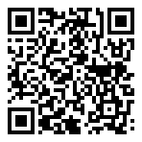
Scan for living source
Qlink took my emergency broadband benefit without my permission or consent. Since they sent me the new 5G Sim card my phone has not worked at all. I’m beginning to think these people are crooks.

lmjcClB2 — Jun 09, 2021 08:40 pm
Dido !!

Source: https://my.remarkbox.com/c98ee92d-c958-11eb-a85e-040140774501
Snapshot: 2026-05-03T10:46:47Z
Generator: Remarkbox 763cacb

