Thread cf3126fb
Source: https://my.remarkbox.com/cf3126fb-8a49-11ef-9a08-29ab4fb285a0
Snapshot: 2026-05-03T09:26:22Z
Generator: Remarkbox 763cacb
This is a subthread snapshot. The living document lives at the source URI above — it may have been edited, extended, or replied-to since.
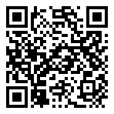
Scan for living source
Has Qlink system gone down in the North Seattle Washington region? I cannot send nor received any messages or calls since Sunday afternoon.

Source: https://my.remarkbox.com/cf3126fb-8a49-11ef-9a08-29ab4fb285a0
Snapshot: 2026-05-03T09:26:22Z
Generator: Remarkbox 763cacb

