Thread d6bac46d
Source: https://my.remarkbox.com/d6bac46d-af3e-11eb-a3b3-040140774501
Snapshot: 2026-05-09T16:50:19Z
Generator: Remarkbox 763cacb
This is a subthread snapshot. The living document lives at the source URI above — it may have been edited, extended, or replied-to since.
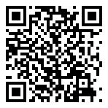
Scan for living source
Calls cannot be completed and when a connection is made the recipient cannot hear me

Source: https://my.remarkbox.com/d6bac46d-af3e-11eb-a3b3-040140774501
Snapshot: 2026-05-09T16:50:19Z
Generator: Remarkbox 763cacb

