Thread d932af8d
Source: https://my.remarkbox.com/d932af8d-c960-11eb-a85f-040140774501
Snapshot: 2026-05-03T09:27:32Z
Generator: Remarkbox 763cacb
This is a subthread snapshot. The living document lives at the source URI above — it may have been edited, extended, or replied-to since.
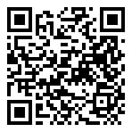
Scan for living source
Down in ohio apparently. I just received my SIM today and cannot activate. Tried calling technical support, call will not go through.

VMrVACAM — Jun 09, 2021 04:26 pm
qlink is swarmed by feds today

Source: https://my.remarkbox.com/d932af8d-c960-11eb-a85f-040140774501
Snapshot: 2026-05-03T09:27:32Z
Generator: Remarkbox 763cacb

