Thread e97e8355
Source: https://my.remarkbox.com/e97e8355-7971-11ec-af62-21646204cc72
Snapshot: 2026-05-03T11:54:53Z
Generator: Remarkbox 763cacb
This is a subthread snapshot. The living document lives at the source URI above — it may have been edited, extended, or replied-to since.
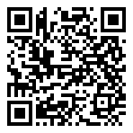
Scan for living source
My phone service is not working. I can not make calls or text messages or receive them. This has been going on since I woke up thismorning around 11am..please let me know when this can be fixed. Thank you

Source: https://my.remarkbox.com/e97e8355-7971-11ec-af62-21646204cc72
Snapshot: 2026-05-03T11:54:53Z
Generator: Remarkbox 763cacb

