Thread f24f4d98
Source: https://my.remarkbox.com/f24f4d98-c985-11eb-a865-040140774501
Snapshot: 2026-05-03T10:48:31Z
Generator: Remarkbox 763cacb
This is a subthread snapshot. The living document lives at the source URI above — it may have been edited, extended, or replied-to since.
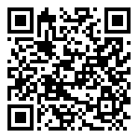
Scan for living source
Thanks for the link, I didn't know this ! Reading this, wondering if we may all loose our phone service ?

oFDsixis — Jun 30, 2021 05:04 pm
I dpn't think so. It says it's going to be beneficial to its users. I know I have a T-Mobile Sim card in my phone and T-mobile is down in my area.

Source: https://my.remarkbox.com/f24f4d98-c985-11eb-a865-040140774501
Snapshot: 2026-05-03T10:48:31Z
Generator: Remarkbox 763cacb

