Thread f964890c
Source: https://my.remarkbox.com/f964890c-9591-11e8-bf30-040140774501
Snapshot: 2026-05-03T08:33:09Z
Generator: Remarkbox 763cacb
This is a subthread snapshot. The living document lives at the source URI above — it may have been edited, extended, or replied-to since.
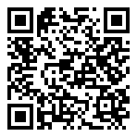
Scan for living source
Hi. Good question! I just use exim4. I've been running my own email servers for a number of years, so I don't find it too difficult. I do take care to look at bounces and disable those accounts. I also include a link in each email to disable all alerts. My hope is that people would click that rather than mark it as spam. And of course every email address is verified at signup.

Source: https://my.remarkbox.com/f964890c-9591-11e8-bf30-040140774501
Snapshot: 2026-05-03T08:33:09Z
Generator: Remarkbox 763cacb

