Thread fa1c99c8
Source: https://my.remarkbox.com/fa1c99c8-9e4b-11eb-9e55-040140774501
Snapshot: 2026-05-03T09:26:39Z
Generator: Remarkbox 763cacb
This is a subthread snapshot. The living document lives at the source URI above — it may have been edited, extended, or replied-to since.
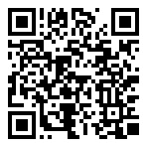
Scan for living source
Most calls not making it to my phone. Some voice messages getting to me; but without my phone registering a call. My phone is working.

Source: https://my.remarkbox.com/fa1c99c8-9e4b-11eb-9e55-040140774501
Snapshot: 2026-05-03T09:26:39Z
Generator: Remarkbox 763cacb

