Thread fab08591
Source: https://my.remarkbox.com/fab08591-03ed-11ec-ba49-040140774501
Snapshot: 2026-05-03T10:47:50Z
Generator: Remarkbox 763cacb
This is a subthread snapshot. The living document lives at the source URI above — it may have been edited, extended, or replied-to since.
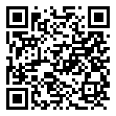
Scan for living source
is there a system wide outage on qlink wireless right now 8-22-21 8-23-21

Source: https://my.remarkbox.com/fab08591-03ed-11ec-ba49-040140774501
Snapshot: 2026-05-03T10:47:50Z
Generator: Remarkbox 763cacb

