Thread fb01b88e
Source: https://my.remarkbox.com/fb01b88e-a702-11ed-9ba9-83aad5f5c937
Snapshot: 2026-05-03T10:47:21Z
Generator: Remarkbox 763cacb
This is a subthread snapshot. The living document lives at the source URI above — it may have been edited, extended, or replied-to since.
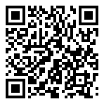
Scan for living source
Cannot send or receive messages--and cannot make or get calls---error message says message blocker is activated??

Source: https://my.remarkbox.com/fb01b88e-a702-11ed-9ba9-83aad5f5c937
Snapshot: 2026-05-03T10:47:21Z
Generator: Remarkbox 763cacb

