Thread fbbf7769
Source: https://my.remarkbox.com/fbbf7769-ed1f-11ec-bef4-83aad5f5c937
Snapshot: 2026-05-03T09:28:35Z
Generator: Remarkbox 763cacb
This is a subthread snapshot. The living document lives at the source URI above — it may have been edited, extended, or replied-to since.
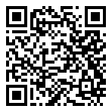
Scan for living source
My qlink has been out of service since June 13. 😒 it's the 15th now, And I've tried everything! But zero cell service. Indiana

Source: https://my.remarkbox.com/fbbf7769-ed1f-11ec-bef4-83aad5f5c937
Snapshot: 2026-05-03T09:28:35Z
Generator: Remarkbox 763cacb

